Thank you for booking your appointment for Ear Wax Microsuction.

Please see enclosed a bottle of ear wax softener.

These ear wax softener drops need to be used twice a day for 3 days prior to your app. This helps soften the wax to make removal easier and to reduce the chance of you needing to come back for a repeat appointment.
If possible, please lie on your side for at least 5 minutes when using these drops to ensure it penetrates all the way through. Massage the tragus to help the drops penetrate all the way through. Bedtime is a good time to do this!

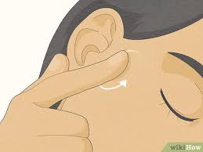

Please do not use ear drops if you know you have a perforated ear drum.

If you are prone to ear wax buildup, you can use these drops once or twice a week to help prevent buildup. It is yours to keep!
If you have any questions, please do not hesitate to ask the pharmacist.
We will see you soon at your appointment! Please allow 30 minutes, although it is likely we will be done before then.

APPOINTMENT DATE, DAY & TIME AS PER HEALTHENGINE:
_________________________________________________________________________



